**Report 4**

**Subtask 1: Prepare Time Series Data**

import pandas as pd

import matplotlib.pyplot as plt

# Step 1: Load the dataset

df = pd.read_csv("ecommerce_data_final_cleaned.csv")

# 1️⃣ Convert 'date' column to datetime format

df['date'] = pd.to_datetime(df['date'], format='%d/%m/%Y')

# Optional: Rename columns for convenience

df.rename(columns={'value [USD]': 'sales'}, inplace=True)

# 2️⃣ Aggregate daily sales

daily_sales = df.groupby('date')['sales'].sum().reset_index()

# 3️⃣ Create full date range to identify missing dates

full_dates = pd.date_range(start=daily_sales['date'].min(), end=daily_sales['date'].max())

full_df = pd.DataFrame({'date': full_dates})

# Merge with daily sales to fill missing days with 0

time_series = pd.merge(full_df, daily_sales, on='date', how='left')

time_series['sales'].fillna(0, inplace=True)

# 4️⃣ Set 'date' as index and sort chronologically

time_series.set_index('date', inplace=True)

time_series.sort_index(inplace=True)

# 5️⃣ Optional: Extract features for deeper analysis

time_series['month'] = time_series.index.month

time_series['weekday'] = time_series.index.dayofweek

time_series['week'] = time_series.index.isocalendar().week

# 6️⃣ Plot to check trend and seasonality

plt.figure(figsize=(14, 5))

plt.plot(time_series['sales'], color='steelblue')

plt.title("Daily Sales Over Time")

plt.xlabel("Date")

plt.ylabel("Sales (USD)")

plt.tight_layout()

plt.show()

# 7️⃣ Save cleaned time series dataset

time_series.to_csv("processed_time_series_sales.csv")

print("✅ Time series data is prepared and saved as 'processed_time_series_sales.csv'")

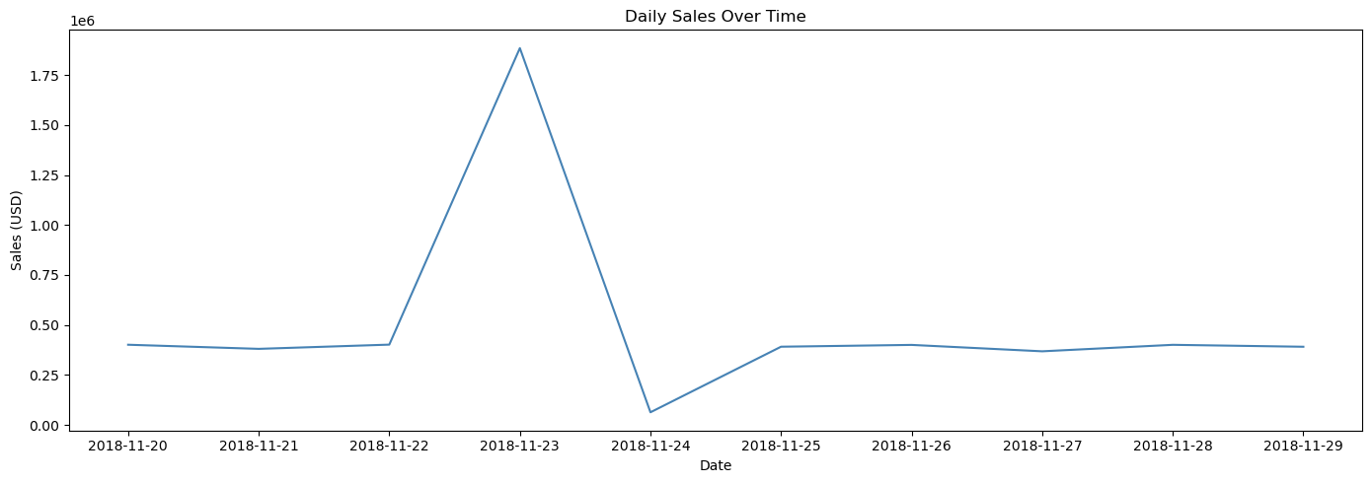

✅ Time series data is prepared and saved as 'processed_time_series_sales.csv'

**Subtask 2: Choose and Apply a Forecasting Model**

import pandas as pd

from prophet import Prophet

from sklearn.metrics import mean_absolute_error, mean_squared_error

import matplotlib.pyplot as plt

import numpy as np

# Step 1: Load pre-processed time series data

df = pd.read_csv("processed_time_series_sales.csv")

df['date'] = pd.to_datetime(df['date'])

# Step 2: Rename columns as required by Prophet

df_prophet = df[['date', 'sales']].rename(columns={'date': 'ds', 'sales': 'y'})

# Step 3: Split into train (80%) and test (20%)

split_point = int(len(df_prophet) * 0.8)

train = df_prophet[:split_point]

test = df_prophet[split_point:]

# Step 4: Initialize and fit the Prophet model

model = Prophet(yearly_seasonality=True, weekly_seasonality=True, daily_seasonality=False)

model.fit(train)

# Step 5: Create future dataframe for next 180 days (~6 months)

future = model.make_future_dataframe(periods=len(test), freq='D')

# Step 6: Make predictions

forecast = model.predict(future)

# Step 7: Plot forecast vs. actual

plt.figure(figsize=(12, 6))

plt.plot(df_prophet['ds'], df_prophet['y'], label='Actual Sales')

plt.plot(forecast['ds'], forecast['yhat'], label='Forecasted Sales', alpha=0.8)

plt.axvline(x=df_prophet['ds'][split_point], color='r', linestyle='--', label='Train-Test Split')

plt.title("📈 Actual vs. Forecasted Sales")

plt.xlabel("Date")

plt.ylabel("Sales (USD)")

plt.legend()

plt.tight_layout()

plt.show()

# Step 8: Evaluate accuracy on the test set

# Merge forecast with test data for comparison

compare_df = forecast[['ds', 'yhat']].set_index('ds').join(test.set_index('ds'))

compare_df.dropna(inplace=True)

# Accuracy metrics

mae = mean_absolute_error(compare_df['y'], compare_df['yhat'])

rmse = np.sqrt(mean_squared_error(compare_df['y'], compare_df['yhat']))

mape = np.mean(np.abs((compare_df['y'] - compare_df['yhat']) / compare_df['y'])) * 100

print(f"📊 MAE: {mae:.2f}")

print(f"📊 RMSE: {rmse:.2f}")

print(f"📊 MAPE: {mape:.2f}%")

# Step 9: Save forecast

forecast.to_csv("forecasted_sales_6_months.csv", index=False)

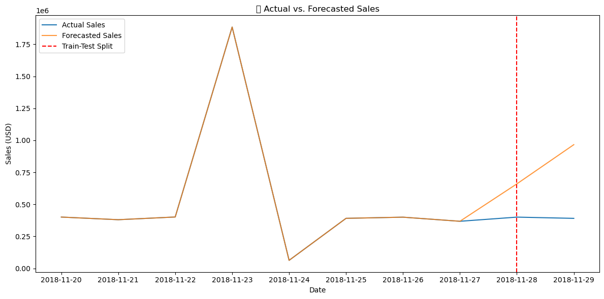

📊 MAE: 417476.39

📊 RMSE: 446346.29

📊 MAPE: 106.01%

**Subtask 3: Predict Future Sales**

import pandas as pd

from prophet import Prophet

import matplotlib.pyplot as plt

from sklearn.metrics import mean_absolute_error, mean_squared_error

import numpy as np

# Step 1: Load prepared and cleaned sales dataset

df = pd.read_csv("processed_time_series_sales.csv")

df['date'] = pd.to_datetime(df['date'])

# Step 2: Format for Prophet

df_prophet = df[['date', 'sales']].rename(columns={'date': 'ds', 'sales': 'y'})

# Step 3: Train-Test Split (80/20)

split_point = int(len(df_prophet) * 0.8)

train = df_prophet[:split_point]

test = df_prophet[split_point:]

# Step 4: Initialize Prophet model

model = Prophet(yearly_seasonality=True, weekly_seasonality=True)

model.fit(train)

# Step 5: Predict for next 365 days (1 year)

future = model.make_future_dataframe(periods=365, freq='D')

forecast = model.predict(future)

# Step 6: Plot actual vs. forecast

plt.figure(figsize=(14, 6))

plt.plot(df_prophet['ds'], df_prophet['y'], label='Actual Sales')

plt.plot(forecast['ds'], forecast['yhat'], label='Forecasted Sales', color='orange', alpha=0.9)

plt.axvline(x=df_prophet['ds'][split_point], color='red', linestyle='--', label='Train-Test Split')

plt.title("📈 Historical vs. Forecasted Sales (Next 12 Months)")

plt.xlabel("Date")

plt.ylabel("Sales (USD)")

plt.legend()

plt.grid(True)

plt.tight_layout()

plt.show()

# Step 7: Evaluate model performance on test data

compare_df = forecast[['ds', 'yhat']].set_index('ds').join(test.set_index('ds'))

compare_df.dropna(inplace=True)

mae = mean_absolute_error(compare_df['y'], compare_df['yhat'])

rmse = np.sqrt(mean_squared_error(compare_df['y'], compare_df['yhat']))

mape = np.mean(np.abs((compare_df['y'] - compare_df['yhat']) / compare_df['y'])) * 100

print("📊 Forecast Accuracy Metrics:")

print(f"✅ MAE: {mae:.2f}")

print(f"✅ RMSE: {rmse:.2f}")

print(f"✅ MAPE: {mape:.2f}%")

# Step 8: Save forecasted values

forecast[['ds', 'yhat', 'yhat_lower', 'yhat_upper']].to_csv("future_sales_forecast.csv", index=False)

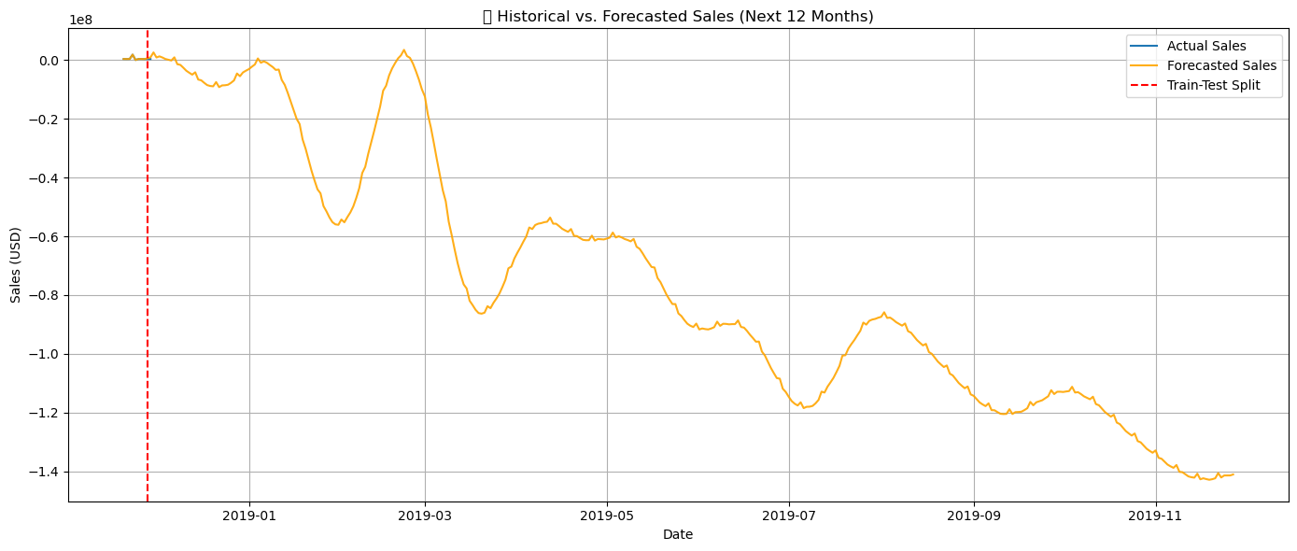

📊 Forecast Accuracy Metrics:

✅ MAE: 417476.39

✅ RMSE: 446346.29

✅ MAPE: 106.01%